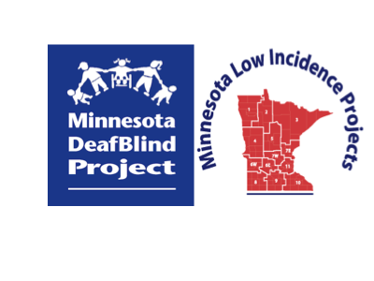

Minnesota Teachers of Students Who Are DeafBlind

Community of Practice

Monday, February 27, 2023

9:00 am - 3:00 pm
Virtual via Zoom (link will be provided to registrants prior to the event)

This workshop has no cost to participants.

Participants should familiarize themselves with the Communication Matrix prior to joining the afternoon session.

Agenda:
9:00-9:15 a.m. Welcome
9:15-10:15 Practical Literacy for DeafBlind Students: Use of TarHeel Shared Reader – Kayna Plaisted, Regional Professional Development Facilitator
10:15-10:25 Break
10:25-11:15 Practical Literacy for DeafBlind Students – Kayna Plaisted
11:15-11:45 Interview of DeafBlind Teen about Tactile Communications Experience: Identity Shifts and ProTactile
11:45-12:30 Lunch Break
12:30-1:30 p.m. Life after the Communication Matrix Assessment – Nancy Steele, DeafBlind Independent Educational Consultant
1:30-1:40 Break
1:40-2:45 Life after the Communication Matrix Assessment – Nancy Steele
2:45-3:00 Evaluation and Wrap-Up

Registration Information with Session Descriptions
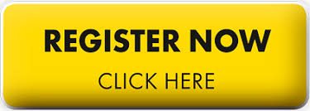
Program and Registration Contact: Ann Mayes, ann.mayes@metroecsu.org
Presenters:
Kayna Plaisted
Kayna Plaisted is the Regional Professional Development Facilitator at Metro ECSU. Kayna coordinates the metro region’s Minnesota Low Incidence efforts, such as the Communities of Practice, Mailing Lists, Charting the Cs, and the Winning Strategies Conference.
She has held many roles, including Classroom Teacher, Curriculum Support Specialist, Instructional Coach, and Adjunct Professor, over her years of experience servicing the field of special education. Kayna believes the highlights of her experience come from growing up alongside her three siblings with disabilities and working intensively with various families outside the school setting.
After attending 30+ days of intensive training hosted by Drs. Karen Erickson and David Koppenhaver, such as MN Literacy Camp and Camp Alec, she is confident with research and evidence-based strategies; all students can become literate individuals, not just those who can see or hear or walk or talk, all means all.
Nancy Steele
Nancy Steele is an Educational Consultant, with expertise in children with significant disabilities. She was a Project Specialist for the National Center on Deaf-Blindness for 14 years. She served as the Lead on the Literacy Initiative, which included the development of the website “All Children Can Read”. She also worked on the Open Hands, Open Access Intervener Modules. She is a co-author of the West Virginia Communication Matrix Intervention Modules.

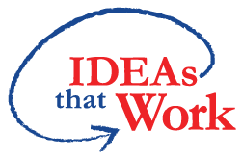 Funding for this workshop is made possible with a grant from the MN Department of Education. The source of the funds is the federal award Special Education – Programs to States, CFDA 84.027A Special Education. And federal award – Project Title: Technical Assistance and Dissemination to Improve Services and Results for Children with Disabilities CFDA 84.326T of P.L. 108-446 Individuals with Disabilities Education Act.

